COINS-Constantine I (306-337) AE3-Temple VOTIS XX with Globe-C Holding Globe-Aniconic-Treveri Trier Germania

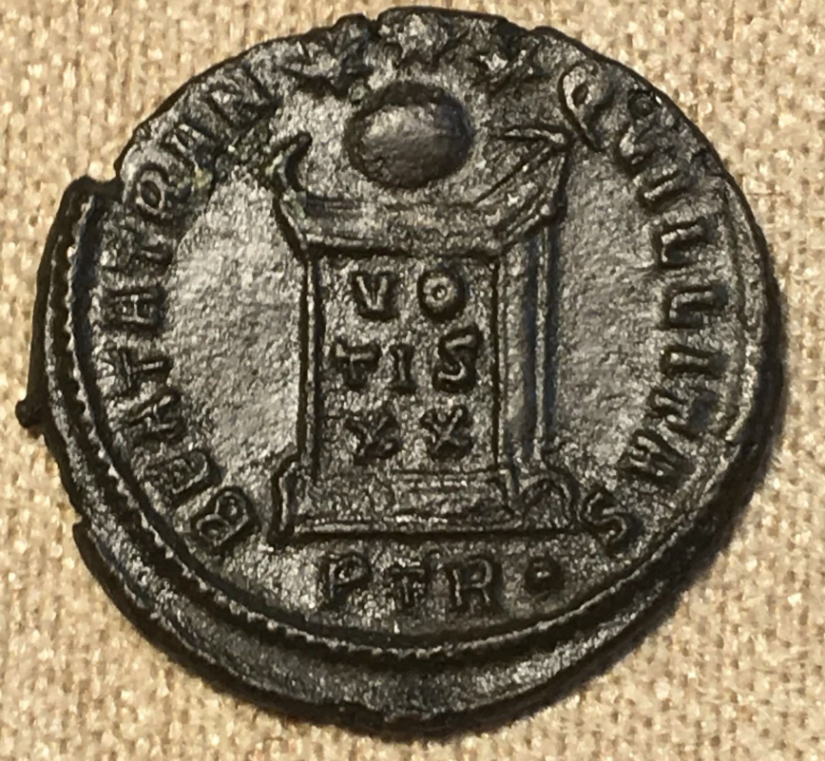 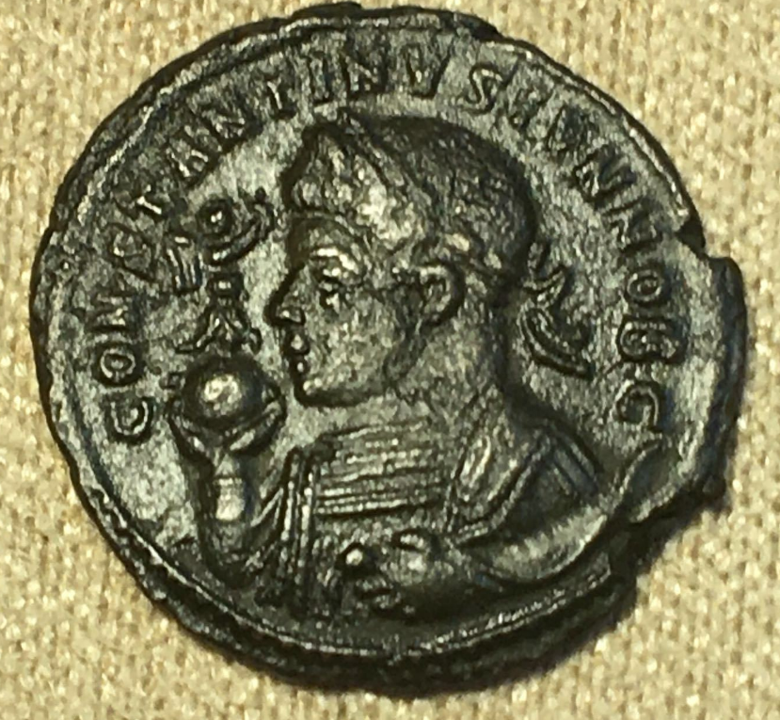

ROMAN EMPIRE

TREVERI, TRIER GERM

OFFICINA P (PRIMA OR 1)

COPPER 1 FOLLIE

EMPEROR CONSTANTINE

ND-306-337 AD

EF/EF+